Outline

Presentation Outline:

Climate change impact on Columbia River Fish Migration

What we tracked:

Chinock Salmon

Sockeye Salmon

Steelhead

Where: The Columbia River

From the mouth of the Columbia

To McNary Dam

Time Frame:

1970 to Current Day

Key Data Points:

Fish Count at each dam

Water Temperature

Weather events

General Weather Stuff:

What I have found is that its’ not the magnitude of a single event in the northwest that is telling, it’s the frequency, the wind speed, the amount of rainfall, and the atmospheric temperature combined.

I wondered why the Columbia river overflowing, and lower basins flooding did not really hit USGS, or NOAA data as an extraordinary event.

Did these events along with Mt. St. Helens eruption drive a difference in the fish population in the Columbia river.

First the weather events:

Since I’ve lived here off and on for the last 45 years, I can speak to the weather first hand. The most extraordinary events were the floods, and earth slides that came as a result of storms. Not one storm by itself drove these events:

USGS:

**Flood** damage in **Washington State** exceeds damage by all other natural hazards. Since 1970, every county in **Washington state has** received a Presidential Disaster Declaration for **flooding**

FACT: A “100-year” **flood happens** about once every 4 ½ years on at least one western **Washington** river draining to Puget Sound. MYTH: **Flooding occurs** randomly in time and location across western **Washington**. FACT: **Floods** cluster in time and location.

1964 The Christmas Flood

Snowfall heavy in Roseburg freezing temps

Followed by high temps and lots of rain

South Umpqua River and creeks fill with debris

17 Oregonians died, 47 in the region

Homes damaged

Oregon: 7032

California: 5090

Washington: 153

Idaho: 150

Total Homes Lost or damaged: 12,425

Trailers: 713

457 Million in damages across 4 states (Oregon, Wash, Idaho, California)

1996 Portland, Oregon City Flooded

Jan 1996, the end of a rain soaked winter

Jan 1996, late in the month, a severe snow storm, freezing temps.

Feb 1996, first of Feb, the **Pineapple Express** hit the coast and drove inland

Willamette Falls seemed to disappear

Willamete River crested 11’ above flood stage

2007 Chehalis, Washington Flooded

Dec 1 First of 3 storms, Cold Artic air in place 4” of snow at Pugent Sound

Dec 2 Snow changed to rain, with high winds up to 165mph

Dec 3 The third storm, The **Pineapple Express** arrived with tropical temps and moisture.

Created record breaking rainfall, 7.5 inches in Bremerton, Shelton, 6.42

Chehalis 10 feet over flood stage, higher than Feb. 1996

2 Miles of I5 closed for 4 days

Most storms come to the Pacific Northwest by way of the [**Pineapple Express**](https://oceanservice.noaa.gov/facts/pineapple-express.html), a narrow band of atmosphere that draws moisture from warm tropical waters around Hawaii and delivers it northward. These atmospheric rivers are known to be responsible for up to half of the total rainfall of western North America and are the main source of heavy rain throughout Washington state, said University of Washington climatologist Guillaume Mauger.

A good Graphic:

<https://wordpress.accuweather.com/wp-content/uploads/2019/12/atmriver.gif?w=632>

Graphic with explanation

<https://oceanservice.noaa.gov/facts/pineapple-express.html>

USGS

Floods are the most destructive natural hazard in the Nation, causing more deaths and financial loss in the 20th century than any other natural disaster. The most significant 20 riverine floods of the 20th century for which data are available have killed more than 1,843 people and caused more than $50 billion (uninflated) in damages (Perry, 2000). One of the most common means of describing the severity of a flood is a comparison to the “100-year flood.” In the last decade, increasing attention has been paid to the fact that some regions, notably the Pacific Northwest, have experienced numerous so-called “100-year” floods in the span of a few years. Part of the confusion stems from the statistical nature of the “100-year flood” (Greene, 1996); however, another part of the confusion is the fact that the statistics are calculated for specific sites (streamgages) on specific rivers, rather than for a region as a whole. Scientists with the U.S. Geological Survey have begun to investigate how the likelihood of flooding may be determined on a regional basis (Troutman and Karlinger, 2003).

Background information about some of the variables involved:

The Hydrosphere:

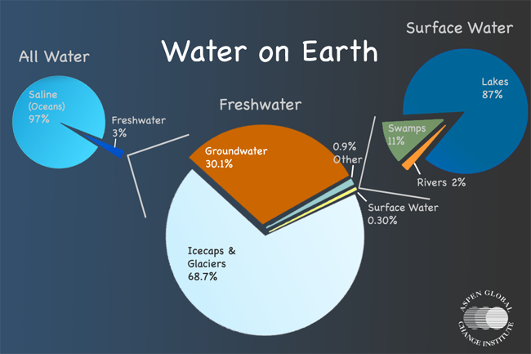

The variable hydrosphere

Precipitation around the globe is highly variable – from deserts (0 to 50 cm per year) to wet rainforests (125-660 cm per year). This variability is a key attribute of productive terrestrial ecosystems. While most precipitation evaporates from and falls onto the oceans, precipitation on land dominates as a key determinant of terrestrial biological zones of the Earth. While some organisms called extremophiles have found ways to adapt to very dry, hot, frozen, or low or high pH environments, the most abundant ecosystems on Earth exist where temperatures are tropical to temperate, nutrients are plentiful, and water is available.

How is the hydrosphere changing?

**Human contributions to greenhouse gases** in the atmosphere are warming the earth's surface - a process which is projected to increase evaporation of surface water and accelerate the hydrologic cycle. In turn, a warmer atmosphere can hold more water vapor. Some evidence suggests global warming is already responsible for more extreme precipitation events. Precipitation in a warming world is also projected to lead to departures from current timing and patterns of rainfall distribution.

While the exact changes are difficult to project, it is highly likely that some places will get drier while other places get wetter over the course of the 21st century as a result of global warming. For example, current climate models indicate that with global warming, high latitudes in the Northern Hemisphere are likely to see more precipitation.

Changes in types of precipitation may occur as well. Some precipitation may shift to rain rather than snow. This would decrease mountain snowpack and affect the timing and quantity of seasonal runoff. Changes in the patterns of spring runoff from major snow-fed river systems, such as those that flow from the Himalayas, will impact the lives and livelihoods of upwards of a billion people who depend upon snowmelt-fed rivers for domestic, agricultural, and industrial use.

As the Earth warms, so too will the ocean. As water warms, it expands. Expansion of warming water makes up about half of the present rise in sea level. The rest of the sea level rise we are currently witnessing is the result of land-based snow and ice melting into the ocean. The melt water component of sea level is expected to make up a more significant component of sea level rise as this century unfolds. The 2013 Intergovernmental Panel on Climate Change report found a 0.19 m rise in sea level between 1901 and 2010 and projected an additional 0.52-0.98 m of sea level rise over this century. However, recent research suggests that the amount of glacier melt could be significantly greater, raising sea level a meter or more. Island nations with little elevation above sea level are in peril, as are many countries with large coastal populations, such as the United States. Lowland settlements will be faced with a choice: whether to hold the line with engineered structures or retreat to higher ground.

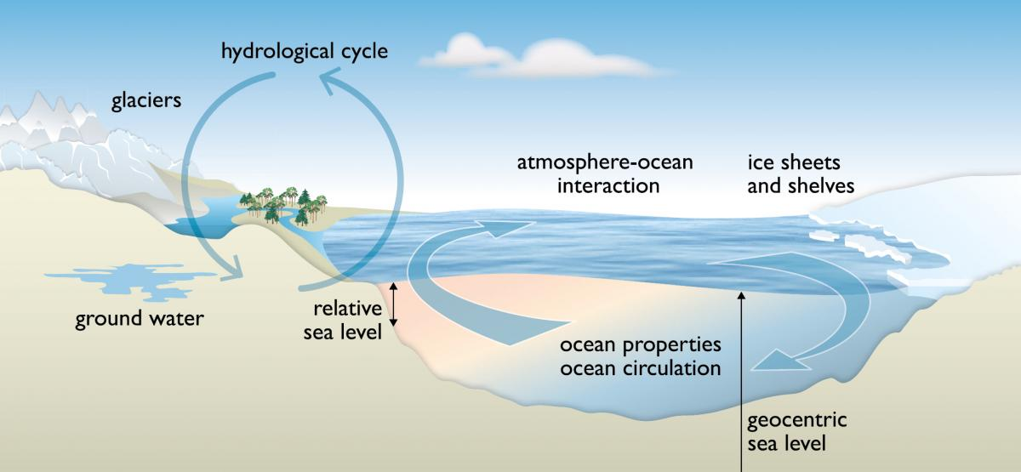

***IPCC 2013 sea-level rise projections:****Climate change is more than just global warming. Forecasts predict shifts in precipitation and run-off patterns that will affect agricultural practices and human livelihoods. (Source: IPCC 2014)*

What is the atmosphere?

The atmosphere is the thin veil of gas molecules that separates the Earth from the cold void of space. Its heat trapping ability helps to keep the Earth warm enough for life, and it also protects the Earth from harmful shortwave solar radiation and cosmic rays. This protective layer was initially formed by gases vented during the geologic tumult of the young Earth but was later altered by the work of photosynthesizing organisms of the early biosphere, providing the oxygen we depend upon. The atmosphere is a dynamic body that interacts with all the “spheres” of Earth. The dynamism of the atmosphere can be witnessed every day as it transfers solar heat from the equator toward the poles, creating regular wind patterns such as the trade winds. Locally, we experience this mass movement of air molecules as a gentle breeze or in more rare and extreme instances, as hurricanes or tornados. The atmosphere in motion also transfers water evaporated from the oceans to the continents, providing precipitation critical to sustain terrestrial ecosystems. Without the atmosphere, the Earth would be like a bigger version of the moon – cold and lifeless.

What makes up the atmosphere?

The atmosphere’s principal constituents of nitrogen (78%) and oxygen (21%) have varied little for millions of years. Within the remaining 1 percent, there are trace gases such as argon and a group of gases known collectively as the greenhouse gases (GHGs), which serve the important role of trapping heat that the Earth receives from the sun and which make the planet hospitable for life.

Water vapor, carbon dioxide, methane, nitrous oxide, and ozone -- the major GHGs -- have the ability to absorb long-wave radiation, warming the Earth 33 ˚C from otherwise subzero conditions. Air bubbles trapped in Antarctic ice reveal how the concentration of carbon dioxide has fluctuated with the ice ages for the last 800,000 years. Over the last 450,000 years, the fluctuation ranges from about 180 parts per million by volume (ppmv) during the depth of an ice age to about 280 ppmv during the naturally occurring warm interglacials.

The atmosphere extends out about 120 km (about 75 miles) from the surface of the Earth and is comprised of four major layers—troposphere, stratosphere, mesosphere, and thermosphere. The lowermost layer, the troposphere, contains the majority of the mass of the entire atmosphere (about 80 percent). As you ascend in altitude from sea level, atmospheric pressure drops exponentially. At 8 km, the height of Mount Everest, there is about one-third the amount of oxygen, and at 80 km, there is virtually no oxygen at all.

How do humans affect the atmosphere?

Ever since humans began to significantly alter the landscape through the development of agriculture after the last ice age about 10,000 years ago, our species has increasingly become an important agent of global-scale change. Extensive combustion of fossil fuels and deforestation are the key factors in the changing concentration of carbon dioxide. **Since the beginning of the industrial revolution in the late 18th century, the combustion of coal, followed by oil and natural gas, has increased the concentration of carbon dioxide in the atmosphere by 38%, to almost 400 ppmv.**

This change in CO2 alters the energy balance of the Earth (the balance of incoming solar energy and outgoing energy radiated to space), and consequently the **Earth’s temperature is now about 0.8˚C above pre-industrial temperatures and rising**. This human alteration of the atmosphere in turn affects agriculture, human health, coastal communities, and the terrestrial and marine ecosystems of the biosphere.